Exercise 1: Configuring a Basic Spring Application
Scenario:
Your company is developing a web application for managing a library. You need to use the Spring Framework to handle the backend operations.
Implementation:
pom.xml
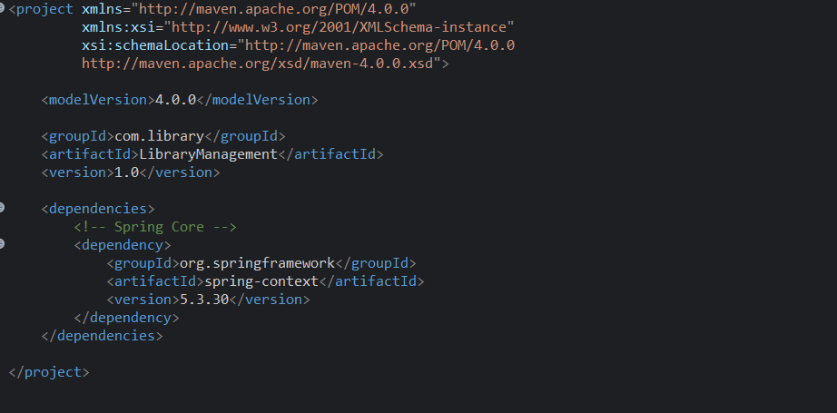

applicationContext.xml
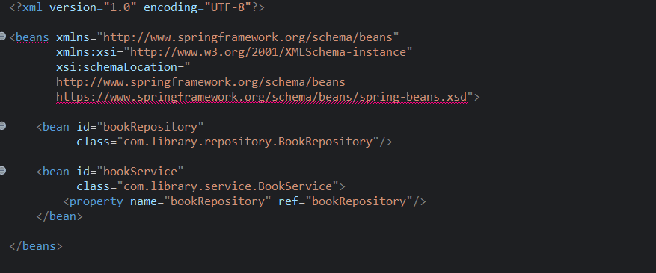

BookService.java
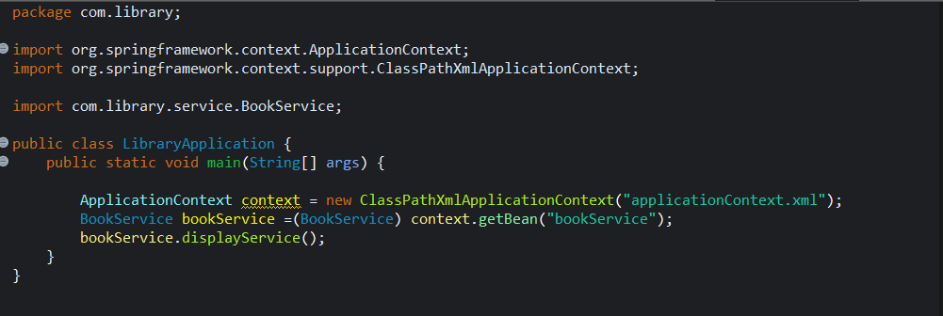
BookRepository.java
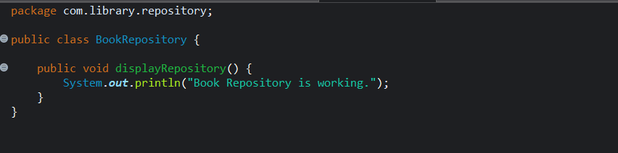
LibraryApplication.java
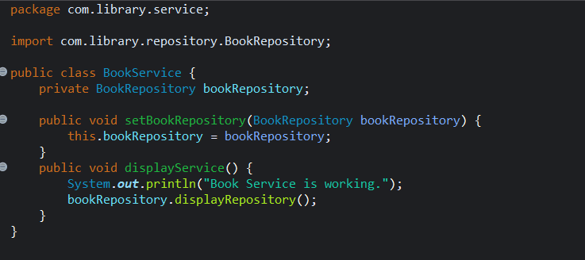

OUTPUT:
